Diagrama de flujo sobre las instrucciones de un proceso relacionado con su quehacer laboral

GA5-240202501-AA1-EV01.

Stewar Saa Sánchez

Aprendiz

Sandra Consuegra

Instructora

SENA Regional

Tecnología en Análisis y Desarrollo de Software

Ficha:2758309

2024



Introduction

In this activity, a flowchart will be made where the step by step for the creation of the project will be presented, complying with the standards and requirements of our clients to meet their needs.

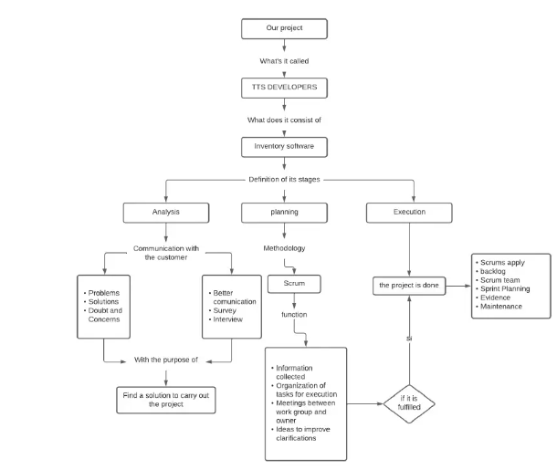

CONCLUSION

It is possible to understand how the creation of the project will be and how it was followed up to achieve compliance and schedule the execution of the project. It is also effectively understood that each point is important to have a good development.